**Theatre Poster Design Basics**

**Size:**

Our main printed poster is 11"x17" and should be designed at 11.25”x17.25”, knowing that 1/8”

will be trimmed off each edge.

The smallest resolution for print is 300 pixels/inch

Please do all of your poster work at these settings.

**Technique:**

Please work in Photoshop or some other graphic program that lets you work in **layers**. Place each and every element of your poster on a separate layer, and save a copy of the final design that way. That is to say: your background color is on one layer, your first picture is on another layer, a different picture is on another layer, each element of your text [title, dates, etc.] is on a separate layer, and so on. Photoshop lets you name each layer, so you don't have to remember what's on Layer 1 or Layer 43.

To email a rough draft of your poster, do the following:

1. Layer: Flatten Image

2. Save As [**NOT** Save] a title other than the psd title [e. g. Draft 1] as a **jpeg file**

3. Image: Set size at 72 pixels/inch instead of 300 [ONLY for the draft! Do **not** do this with the final design you’ve saved in layers!] and save

4. Email this smaller jpeg

To send the FINAL draft of the poster:

1. Layer: Flatten Image

2. Save As [**NOT** Save] Poster Final or Poster Print and as a **pdf file**

3. Do NOT resize to 72!

**Poster text:**

Each poster should contain, in roughly this order:

Hendrix Players Present

Title of Show

Plus any of these that may be applicable

* **“Plays Title”** is presented by special arrangement with *SAMUEL FRENCH, INC.( or other)*

**or**

* Co-Sponsored by The Hendrix-Murphy Programs in Literature and Language

**or**

* Co-Sponsored By The Hendrix-Murphy Foundation

Playwright

* The name of the Author will appear on a separate line on which no other name appears, immediately following the title of the work and will appear in size type not less than fifty percent (50%) of the size of the title type.

Dates and Times—example:

Wednesday-Saturday, November x-xx, 20xx

7:30 PM and a Saturday matinee at 2:00 PM

Location—example:

Cabe Theatre

Ticket information—example:

For ticket reservations call 501-450-1343

or visit www.hendrix.edu/theatrearts

or

For information call 501-450-1343

or visit www.hendrix.edu/theatrearts

The Hendrix logo—see <http://www.hendrix.edu/news/news.aspx?id=578> for the style guide and copies of the logo

Download and include FACEBOOK AND TWITTER LOGOS

**If you have questions, talk to Dr. Campbell [campbellc@hendrix.edu], or ask one of the other Theatre faculty.**

**Examples of Layers: sMacintosh HD:private:var:folders:yb:4m91t0_m8xjbfh0059_wdmmh0000gq:T:TemporaryItems:HENDRIX_COLLEGE_4C w-control.eps**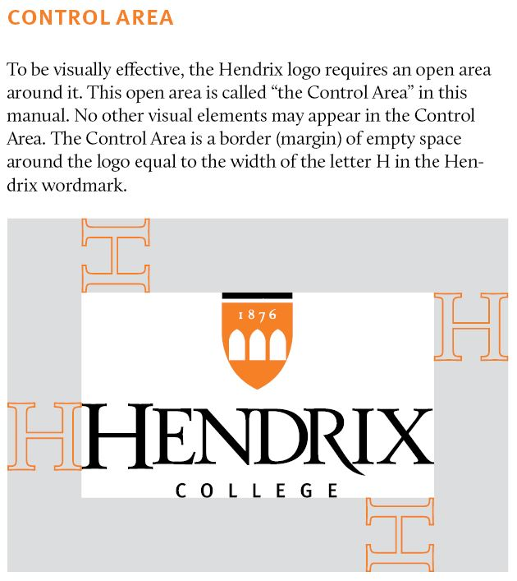**ee next page**

